**Managing Jenkins master and slave nodes**

**Jenkins Distributed Architecture**

Jenkins uses a Master-Slave architecture to manage distributed builds. In this architecture, Master and Slave communicate through TCP/IP protocol.

**Jenkins Master**

Your main Jenkins server is the Master. The Master’s job is to handle:

* Scheduling build jobs.
* Dispatching builds to the slaves for the actual execution.
* Monitor the slaves (possibly taking them online and offline as required).
* Recording and presenting the build results.
* A Master instance of Jenkins can also execute build jobs directly.

**Jenkins Slave**

A Slave is a Java executable that runs on a remote machine. Following are the characteristics of Jenkins Slaves:

* It hears requests from the Jenkins Master instance.
* Slaves can run on a variety of operating systems.
* The job of a Slave is to do as they are told to, which involves executing build jobs dispatched by the Master.
* You can configure a project to always run on a particular Slave machine, or a particular type of Slave machine, or simply let Jenkins pick the next available Slave.

The diagram below is self explanatory. It consists of a Jenkins Master which is managing three Jenkins Slave.

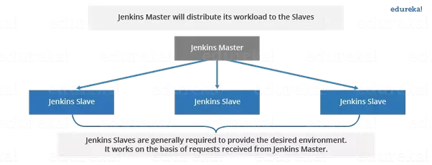

Now let us look at an example in which Jenkins is used for testing in different environments like: Ubuntu, MAC, Windows etc.